# Online Examination System Using EJS View Engine and Express JS

##### **Saurabh Saini*, Sudhanshu** , Shikha Jain\*\*\***

*Computer Science Department, KIET Group of Institutions

***Abstract*-** Online Examination System project is web application that is developed use NodeJS. This project is helpful for teacher conducting exam through the online system. Here OES is implemented using EJS and Express JS Framework. EJS is used to render various components like question and answer on screen.

**Keyword** – online exam, web server, database, web application, examination system (Exam), EJS, Embedded JavaScript.

1. Introduction

**O**nline Examination System is a technology-driven way to simplify examination activities like defining exam patterns with question banks, defining exam timer, objective/ subjective question sections, conducting exams using the computer or mobile devices in a paperless manner. Online Examination System is a cost-effective, scalable way to convert traditional pen and paper-based exams to online and paperless mode. Candidates can appear for the exam using any desktop, laptop, or mobile device with a browser. Exam results can be generated instantly for the objective type of questions. It can simplify overall examination management and result in generation activity. It is used by Coaching, institutes, colleges, universities, government, and corporate to conduct online assessments with ease. In the exam portal, invigilation becomes a high priority requirement as it ensures the exam reliability and credibility of the exam. The administrator has got multiple options to create an online exam that is interactive as well as effective. Online exam creation platform provides a variety of question types using which a subjective, objective, or MCQ type exam can be easily created. Also, the choice of questions can be done from an existing exam library, or the exam creator can create an all-new set of questions by uploading them with just a click. Conducting a large-scale exam is not an issue when it comes to the online exam. Online exam software has got the feature to accommodate even a large pool of students at once. The additional feature of “candidate management” increases the feasibility to conduct an exam for a large group of candidates in a systematic manner. It allows the exam taker to categorize the candidates in their respective groups and at the time of conducting the exam, the exam taker can assign individual exams to every group, conducting multiple exams at once.

For creating OES, we have used EJS for rendering HTML DOM components to the screen. EJS or Embedded JavaScript Templating is a templating engine used by Node.js. Template engine helps to create an HTML template with minimal code. Also, it can inject data into HTML template at the client side and produce the final HTML. EJS is a simple templating language which is used to generate HTML markup with plain JavaScript. It also helps to embed JavaScript to HTML pages.

1. Literature survey

A literature review revealed research and studies based on the implementation of a variety of technologies in college/School courses. “The internet has opened many possibilities for the classroom instruction, but it can also be a barrier to teaching as well”. The new innovative technologies provide opportunities to improve learning and create a more exciting and motivating environment. A study by Hay (2002) reports that an online exam is one in which questions are answered on, stored on, and often marked by computers. Hay discovered the following keys to taking an online exam:

1. Do not be tempted to access software other than that prescribed during the exam.

2.Sometimes attempting to use other packages interferes with the exam software, thereby jeopardizing your answers

3. Even if you have finished your exam and are waiting to leave it is unwise to use the computer in any ways other than those required for the exam.

Online examination system is one of the methods of taking exams which is doesn’t require any kind of a piece of paper or a pen. It is the fast-growing method to take exams over online. Speed and accuracy is the reason behind the famous of this method because speed and accuracy is the backbone of this system. Many researchers have already researched about online examination system and we have developed a online examination system to keep an eye on this researches as a reference and these all are the following: [2]Zhenmin et al (2003):They developed an online examination system based on web browser/server framework.[3] Tomás Sánchez Navarro states how you can use EJS with express framework and how to set view engine.[4] EJS.co stated that how to use variable and programming logic in HTML by embedding using EJS.

1. System Objective

This application is used to conduct online examinations. The students can sit at individual terminals and log in to write the exam in the given duration. To automate examination and make the life of users more comfortable. Exam Engine reduces the manual work, maintaining accuracy, increasing efficiency, and saving time. Also, institutes need not go to develop a new software each time, instead they just register and conduct a test. For students, it saves time of going too far away from centers and also, they can view their result then and there.

* User-friendly system.
* Responsive design
* Exam organization
* Participation of student in an exam.
* Reports and performance analysis

1. system architecture

The following figure show how to use EJS to generate different attributes fetch from database .

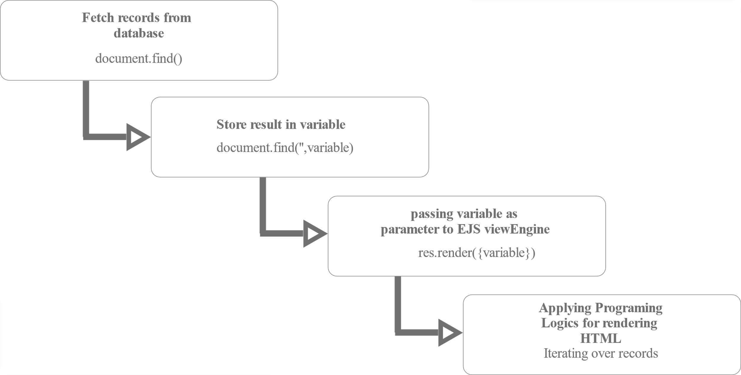

**Step 1**: Fetching records from database like questions, user details, etc.

**Step 2**: Store them into a variable

**Step 3**:Pass the variable as parameter in the render function of express framework.

**Step 4**: Applying programming logic like for loop inside html using EJS

**Rendering Question using EJS in an HTML**

Step 4: Generating HTML for each question

1. features

1. It saves time as it allows multiple students to give their exams at the same time and displays the result immediately as the test gets over.

2. It will reduce paper wastage.

3. System will check responses given by the students automatically and immediately.

4. Question papers are automatically generated by the server.

5. Administrator has the administrative power to create, modify and delete the exam.

6. Users can log in with a specific id and give the test and can see the result as well.

7. It will reduce the work of accessing the answers given by the candidates.

8. The android app will help share the images of the questions and the practice papers created by the administrator.

9. Questions can include diagrams, graphical representations, etc.

10. The online examination system has a password-based authentication.

11. Students and faculty details are stored in the database.

1. CONCLUSION

Online examination tests are unquestionably turning into a medium of assessing candidates’ knowledge and aptitude. They provide flexibility to educational institutes to create, manage and evaluate examinees effortlessly. With quick assessment and real-time report generation, results can be declared immediately after the students have completed the test. Online examination tests have revolutionized the education industry by automating manual, tedious, and cumbersome processes. Online Examination System is significantly superior among the other exams. We have come to result that the problems can be solved by introducing new security systems using biometrics, we can identify the student’s identity by analyzing digital signature or by fingerprint mechanism and also by providing web cameras in the examination hall. Although web cameras Sometimes gets failed, if supposed a candidate is giving exam and facing downwards in such case Iris recognition and face recognition must be used. We conclude that no mechanism is ideal. Each mechanism has some restriction on its own. Key concepts are to develop paperless environment and to convert all the documentation in digital form.

VII. Future Work

As exam portal has to be secure and should have some anti-cheating mechanism so there should be proctoring. So in upcoming version of exam engine will have following functionalities like proctoring, live candidate viewing options. There will be more role in applications. The variety of question type will be increased in upcoming version.

References

1. V.Selvi, R.Sankar and R.Umarani, “The Design and Implementation of On-Line Examination Using firewall security,” in IOSR Journal of Computer Engineering (IOSR-JCE) Volume 16, Issue 6, PP 20-24
2. Mohammad A Sarrayrih and Mohammed Ilyas, “Challenges of Online Exam, Performances and problems for the online university exam,” in IJCSI International Journal of Computer Science Issues, Vol. 10, Issue 1, No 1, 2013.
3. Zhao Qiao-fang and Li Yong-Fei, “Research and Development of Online Examination System,” in Proceedings of the 2012 2nd International Conference on Computer and Information Application (ICCIA 2012).
4. Kurniawan, A. (2014). Node.js Succinctly. Synfusion Inc.
5. Govett, D. (2010, March). Learning Server-Side JavaScript with Node.js. Retrieved from Envato Tuts+: <http://www.webcitation.org/6ePoNkZwD>
6. Teixeira, P. (2013). Hands-on Node.js. In P. Teixeira, Hands-on Node.js. Lean Publishing.
7. Young, A. (2012, May). Windows and Node: Getting Started. Retrieved from Dailyjs: <http://www.webcitation.org/6ePozY7jz>
8. Tom Hughes-Croucher, M. W. (2012). Node: Up and Running. In M. W. Tom Hughes-Croucher, Node: Up and Running. O'Reilly Media Inc.
9. Ortiz, A. (2013, March). Server-side Web Development with JavaScript and Node.js. Retrieved from http://webcem01.cem.itesm.mx:8005/node/node.html
10. Mike Cantelon, T. H. (2013). Node.js in Action. Manning Publications.
11. Rauch, G. (2012). Smashing Node.JS JavaScript Everywhere. John Wiley & Sons Inc.
12. Teixeira, P. (2013). Professional NodeJs: Building JavaScript-Based Scalable Software. John Wiley & Sons Inc
13. Software Requirements Specification for Problem Based Learning Module, Souman Mandal,2010.
14. Ainscough, T. L. (1996). "The Internet for the rest of us: marketing on the World Wide Web." Journal of consumer marketing 13(2): 36- 47.
15. Software Design Specification (SDS) Acropolis Course Management System, 2011.
16. Software Requirements Specification for PPDP Contact Management System (CMS)
17. SWeaver, D., et al. (2005). Evaluation: WebCT and the student experience. Evaluations and Assessment Conference.
18. Yang Zhigang. Network optimization algorithms in test system Lectures 2006:91-92
19. Li Yueru. Algorithmic Online Examination System Design FuJian computer.2009,1:66-67
20. Li Xueling, Guan Qun. Design and Implementation of Online Examination System Based on PHP technology.
21. Yin Xiaoling, Xia Qishou1, Fan Xunli. Analysis and Study of Volume Pattern in Network Test System.Computer.

Authors

**First Author** – Saurabh Saini, Research Scholar, KIET Group of Institution, saurabh.1822cs1124@kiet.edu

**Second Author** – Sudhanshu, Research Scholar, KIET Group of Institution, [sudhanshu.1822cs1146@kiet.edu](mailto:sudhanshu.1822cs1146@kiet.edu)

**Third Author -** Shikha Jain, Assistant Professor, KIET Group Of Institutions, shikha.jain.cse@kiet.edu